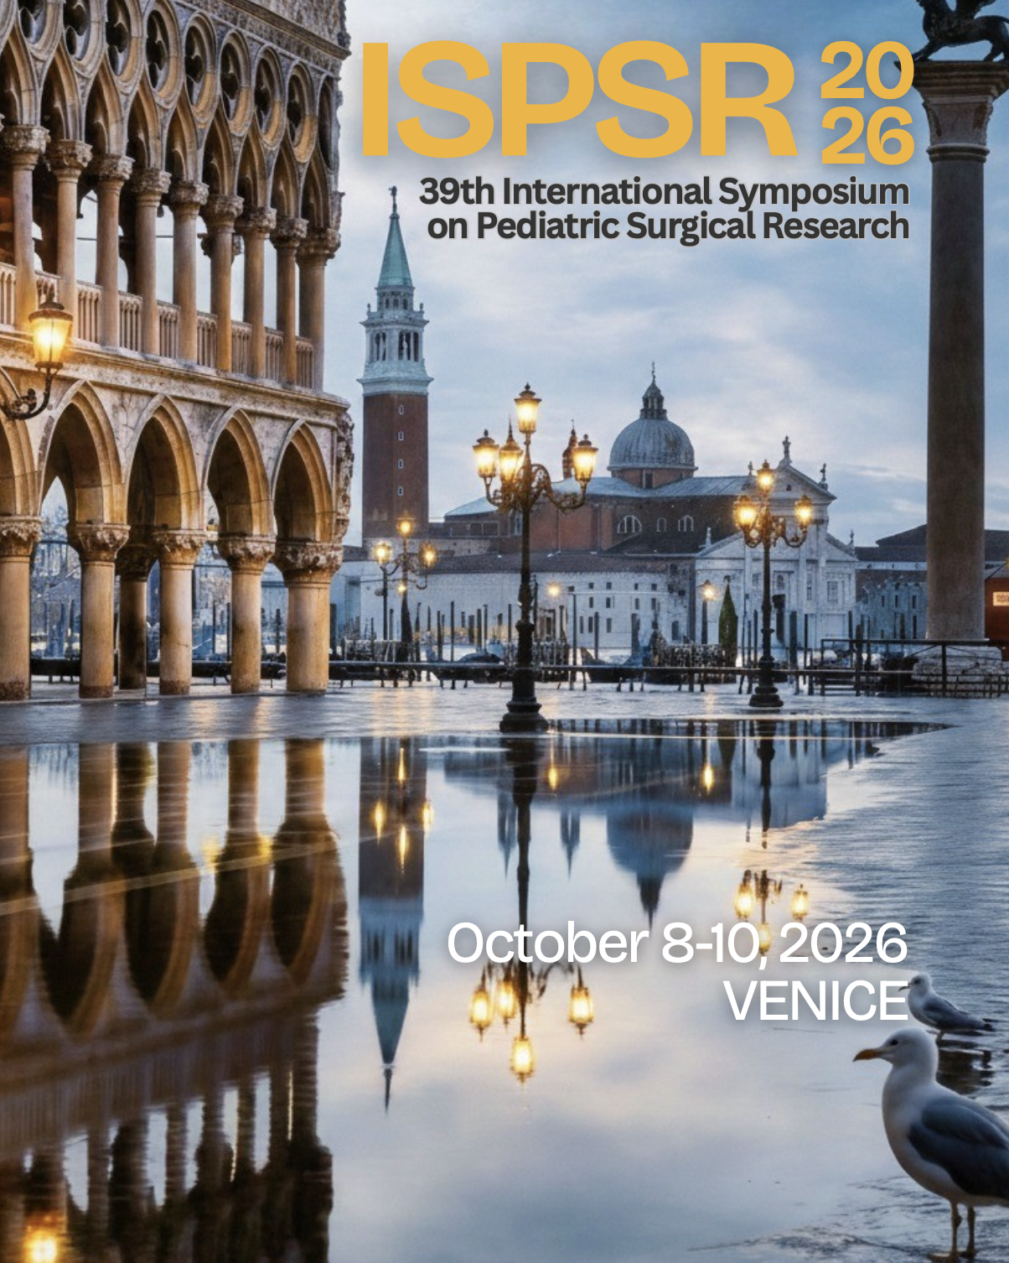

October 8-10, 2026
VENICE

On behalf of the International Symposium on Pediatric Surgical Research, it is our distinct pleasure to present an opportunity to join as an institutional partner of the 39th International Symposium on Pediatric Surgical Research (ISPSR), which will take place in Venice, Italy, from October 8–10, 2026.
Over the years, ISPSR has established itself as a leading international platform for scientific exchange, bringing together clinicians, researchers, and academic institutions committed to advancing pediatric healthcare worldwide.
The 2026 edition, hosted in Venice, will focus on “Recent Advances and Emerging Trends in Pediatric Surgery,” addressing key areas such as fetal therapy, regenerative medicine, pediatric oncology, and minimally invasive and robotic surgery.
Beyond its scientific value, the symposium represents a unique opportunity to enhance the international visibility of Venice and the broader Veneto region. The participation of more than 200 delegates from leading global institutions will contribute to strengthening the role of the area as a hub of excellence in research, innovation, and international collaboration.
In this context, the involvement of Your prominent Company would carry particular significance. Supporting ISPSR 2026 would not only contribute to the advancement of pediatric medical research but also reflect a strong commitment to initiatives with a meaningful social, healthcare, and cultural impact.
An institutional partnership would offer:
• Prominent visibility within a highly qualified international audience
• Association with a prestigious scientific and academic initiative
• Acknowledgment across official congress communication channels and materials
• The opportunity to actively support innovation and progress in pediatric healthcare
The organization of the symposium is entrusted to the conference secretariat Meet and Work (meet@meetandwork.com), which will be pleased to provide detailed information regarding partnership opportunities.
We would be honored to count on your support for this important international initiative and would welcome the opportunity to explore potential forms of collaboration.
We remain at your disposal for any further information.
Yours sincerely,

Prof. Gloria Pelizzo Prof. Prem Puri
Professor & Director of Pediatric Surgery Chairman, ISPSR Board
Department of Biomedical & Clinical Sciences
University of Milano
Local Organising Chair, ISPSR

